**Day 21**

**Task 1: Establishing Database Connections**

Write a Java program that connects to a MySQL database and prints out the connection object to confirm successful connection.

**Program:**

***import* java.sql.*Connection*;  
*import* java.sql.DriverManager;  
*import* java.sql.SQLException;  
*import* java.sql.*Statement*;  
  
*public class* Task1 {  
 *public static void* main(String[] args) {  
 *try* {  
 DriverManager.*registerDriver*(*new* com.mysql.cj.jdbc.Driver());  
   
 *Connection* connection = DriverManager.*getConnection*("jdbc:mysql://localhost:3306/mydb","root","5539");  
   
 System.*out*.println("Connection: "+ connection);  
   
 } *catch* (SQLException e) {  
   
 *throw new* RuntimeException(e);  
   
 }  
 }  
}**

**Output:**

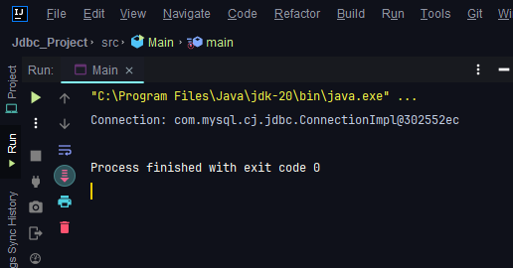

**Task 2: SQL Queries using JDBC**

Create a table 'User' with a following schema 'User ID' and 'Password' stored as hash format, accept "User ID" and "Password" as input and check in the table if they match to confirm whether user access is allowed or not.

**Program:**

***import* java.sql.*;  
  
*public class* JdbcDemo {  
 *public static void* main(String[] args) {  
 *try* {  
 DriverManager.*registerDriver*(*new* com.mysql.cj.jdbc.Driver());  
 *Connection* connection = DriverManager.*getConnection*("jdbc:mysql://localhost:3306/mydb","root","5539");  
 *Statement* statement = connection.createStatement();  
  
 */*  
 String insert = "insert into products values(6,'PC',10000,'2024-07-02','Dell')";  
 int count = statement.executeUpdate(insert);  
 System.out.println(count + " record affected");  
 */* String selectQuery = "Select * from Products";  
 *ResultSet* rs = statement.executeQuery(selectQuery);  
 *while* (rs.next()){  
 *int* pid = rs.getInt("pid");  
 String productName =rs.getString("Product_Name");  
 *double* price = rs.getDouble("price");  
 Date date = rs.getDate("DOP");  
 String brand = rs.getString("Brand");  
  
 System.*out*.println(pid + " "+ productName + " " + price+ " " + date +" " + brand);  
 }  
 } *catch* (SQLException e) {  
  
 *throw new* RuntimeException(e);  
 }  
 }  
}**

**Output:**

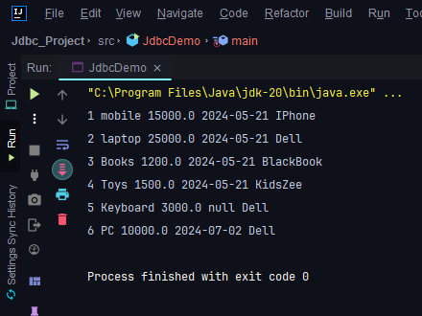

**Task 3: PreparedStatement**

Modify the SELECT query program to use PreparedStatement to parameterize the query and prevent SQL injection.

**Program:**

*package* Crud;  
  
*import* java.sql.*;  
  
*public class* Task7 {  
 *public static int* update(){  
 *int* count = 0;  
 String updateQuery = "Update products set product_name = ?, price = ?, dop = ?, brand = ? where Pid = 1";  
 *try* {  
 *Connection* connection = DriverManager.*getConnection*("jdbc:mysql://localhost:3306/mydb","root","5539");  
 *PreparedStatement* preparedStatement = connection.prepareStatement(updateQuery);  
 preparedStatement.setString(1, "OnePus");  
 preparedStatement.setDouble(2,20000);  
 preparedStatement.setDate(3, Date.*valueOf*("2024-06-07"));  
 preparedStatement.setString(4,"One plus");  
  
 count = preparedStatement.executeUpdate();  
 } *catch* (SQLException e) {  
 *throw new* RuntimeException(e);  
 }  
 *return* count;  
 }  
  
 *public static void* main(String[] args) {  
 System.***out***.println(*update*()+ " records affected");

}  
}

**Output:**

